

**A PROJECT REPORT**

**ON**

**ONLINE PIZZA ORDERING SYSTEM**

**DONE BY**

**Vaishnavi S. Phondekar**

**(EBTSOC0920316681)**

**Under the Guidance of,**

**Mr. V JAYANTH**

**Technical Trainer**

**NASSCOM PROJECT**

**­**

**ARISE**

**ONCAMPUS**

**SOFTWARE DEVELOPER TRAINEE**

**Tambaram, Chennai-600045 (Tamil Nadu)­­**

**2020**

1. **Abstract**

ONLINE PIZZA ORDERING SYSTEM is a website designed primarily for use in the pizza delivery industry. This system will allow pizza delivering hotels to increase scope of business by reducing the labor cost involved. The system also allows to quickly and easily manage an online menu which customers can browse and use to place orders with just few clicks.

1. **Introduction**

It is known globally that, in today’s market, it is extremely difficult to start a new small-scale business and live-through the competition from the well-established and settled owners. In fast paced time of today, when everyone is squeezed for time, the majority of people are finicky when it comes to placing a food order. The customers of today are not only attracted because placing an order online is very convenient but also because they have visibility into the items offered, price and extremely simplified navigation for the order. Online pizza ordering system that I am proposing here, greatly simplifies the ordering process for the customer and the restaurant. System presents an interactive and up-to-date menu with all available options in an easy to use manner. Customer can choose one or more items to place an order which will land in the Cart. Customer can view all the order details in the cart before checking out. At the end, customer gets order confirmation details. Once the order is placed it is entered in the database and retrieved in pretty much real time. This allows Hotel Employees to quickly go through the orders as they are received and process all orders efficiently and effectively with minimal delays and confusion.

1. **Aim of the Software**

This software is developed to help computer science students to learn about the Web application designing using JSP and HTML from their basic capabilities to build a complete working application from 5 scratch. Further, it gives insight about how GUI interacts with server-side language, Java, and finally with the MySql database.

1. **Functionality**

Product Function: The Online Food Order System application would have the following basic functions:

* 1. **Web Ordering System Module :**

This module provides the functionality for customers to place their order and supply necessary details.

Users of the system, namely restaurant customers, must be provided the following functionality:

* Create an account.
* Manage their account.
* Log in to the system.
* Select an item from the menu.
* Add an item to their current order.
* Review their current order.
* Remove an item/remove all items from their current order.
* Place an order.
  1. **Menu Management System Module:**

This module provides functionality for the power user-Administrator only. It will not be available to any other users of the system like Hotel Employees or Customers.

* Add/update/delete pizza category to/from the menu.
* Add /update/delete pizza item to/from the menu.
* Update price for a given pizza item
  1. **Order Retrieval System Module :**

This is the most simplest module out of all 3 modules. It is designed to be used only by hotel employees, and provides the following functions:

* Retrieve new orders from the database.
* Display the orders.

1. **Requirement Analysis :**
   1. **Hardware Requirement:**

* Pentium Processor
* 60 MB of free hard-drive space
* 128 MB of RAM
  1. **Software Requirement:**
* Operating System: Windows
* Web Browser: Google Chrome
* Eclipse
* MySql Workbench
* Apache Tomcat

1. **Snapshot**
   1. **Registeration :**

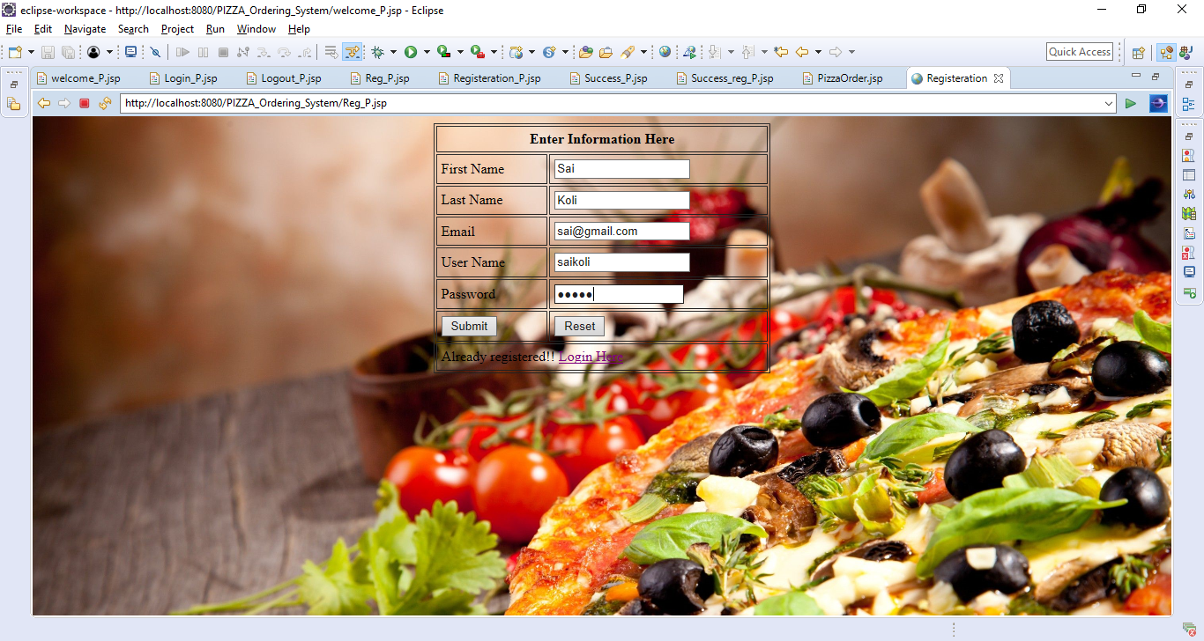

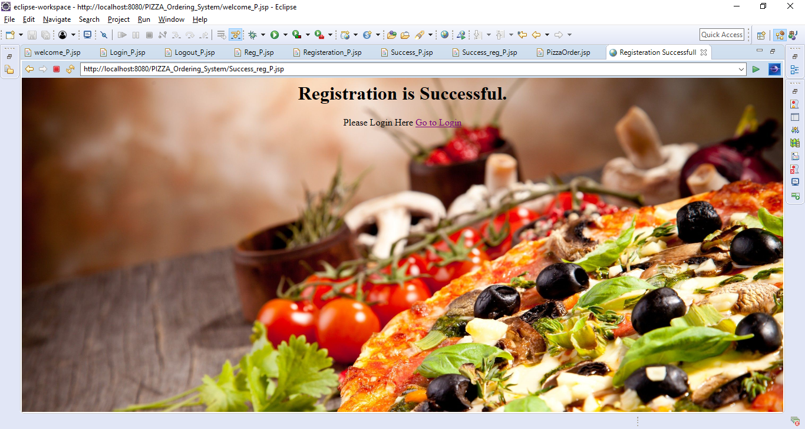

* 1. **Login :**

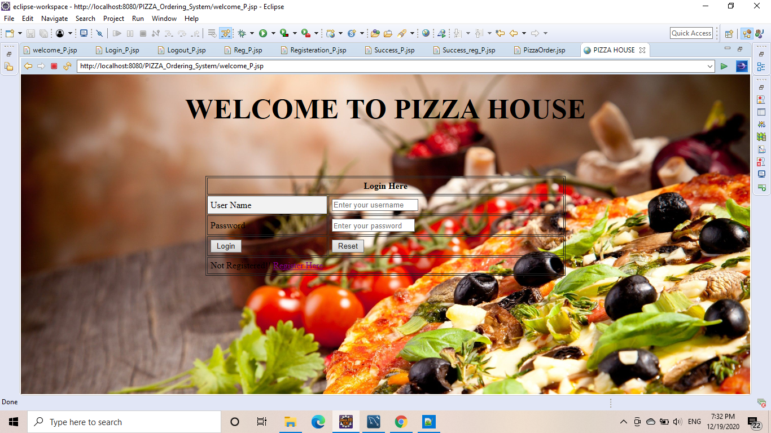

* 1. **Menu :**

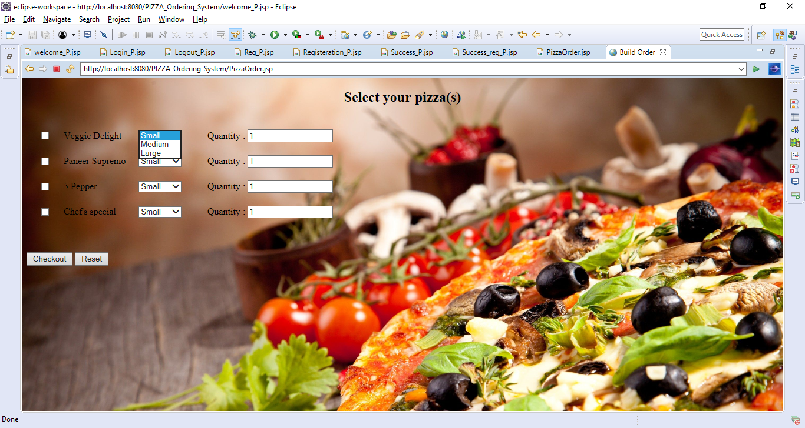

* 1. **Order Successful / Logout :**

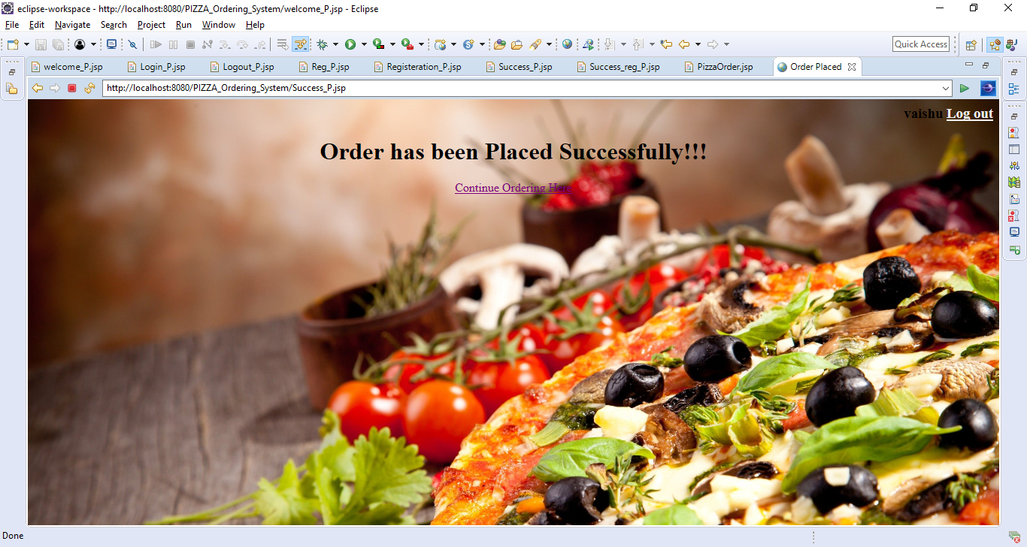

1. **Conclusion :**

The main objective of the application is to help Computer Science students understands the basics of Java, JavaScript and HTML. The following results have been achieved after completing the system and relate back to the system’s objective.

* **Should allow Computer Science students to browse through the code and application:** This can be achieved when students are able to run and install the application. When they run the application, they can browse through the implementation of different objects.
* **Should allow users to browse through different product categories:** This is achieved through an easy to use graphical interface menu options.
* **Should allow users to save items to the cart and view detailed information about the order:** The users can add any number of items to the cart from any of the available food categories by simply clicking the Add to Cart button for each item. Once item is added to the cart, user is presented with detailed order to review or continue shopping.